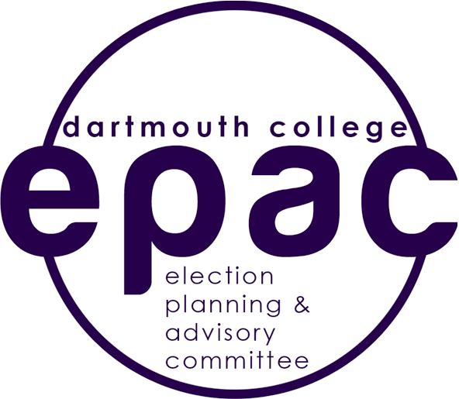

Contact: The 2018 EPAC
Tuesday, April 17, 2018
FOR IMMEDIATE RELEASE

Email: Elections.Planning.and.Advisory.Committee@Dartmouth.edu

2018 Elections Results

The Elections Planning & Advisory Committee (EPAC) is an independent committee charged with creating and governing campus elections. The 2018 EPAC Board would like to formally announce the winners of this year’s elections (bolded and italicized below).
We would like to thank all the candidates for their hard work over the past week in upholding the integrity and fairness of the election process. We also thank all students who took the time to vote. This year saw a near record number of students cast a ballot, with 1789 ballots in total.
Congratulations to the winners and best of luck in your positions for the next school year. (Votes | Candidate)

Student Body President (1789 ballots cast)

1030 | Monik Walters ‘19
336 | Alex Petros ‘19
327 | John Duggan ‘19

Student Body Vice-President (1789 ballots cast)

945 | Nicole Knape ‘19
338 | Hannah Pruitt ‘19
326 | Rachel Kesler ‘19
126 | Carlos Polanco ‘21

Senior Class President (514 ballots cast)

321 | Danny Li ‘19
180 | Steven Chun ‘19

Senior Class Vice-President (507 ballots cast)

207 | Josephine Kalshoven ‘19
153 | Matt Brown ‘19
82 | Mark Dominguez ‘19
58 | Bradford Stone ‘19

2020 Class Council Executives (424 ballots cast)

296 | Lily Clark ‘20
294 | Lizzie Clark ‘20
233 | Brandon Yu ‘20
211 | Iris Wang ‘20

2021 Class Council Executives (380 ballots cast)

270 | Sarah Solomon ‘21
263 | Nate Stockmal ‘21
263 | Emmanuel Berrelleza ‘21

Committee on Standards/Organizational Adjudication Committee:

899 | Anjali Chikkula ‘20
884 | Anna Whitney ‘20
785 | Albert Chen ‘20
726 | Jackson Baur ‘20
721 | Jonathan Fried ‘20

House Senate Seat Winners:

Allen:

Write-in Candidate ‘19
Kojo Edzie ‘20
Write-in Candidate ‘21

East Wheelock:

Lauren Huff ‘19
Anjali Chikkula ‘20
Caitlyn McGovern ‘21

North Park:

Write-in Candidate ‘19
Write-in Candidate ‘20
Riley Flewelling ‘21

School:

Write-in Candidate ‘19
Write-in Candidate ‘20
Ally Gaines ‘21

South:

Nelly Mendoza-Mendoza ‘19
Colby Conner ‘20
Rohan Chakravarty ‘21

West:

Write-in Candidate ‘19
Timothy Holman ‘20
Philip Lindsay ‘21

Write-in candidates will be announced once they have been screened by Judicial Affairs and confirmed interest in serving. Thank you again to the candidates and everyone who voted.

Sincerely,
2018 EPAC Board:
Luke Cuomo ‘20 (Chair) Jeffrey Fastow ‘18
Henry Wilson ‘18
Michelle Wang ‘19
Farid Djmalov ‘21
Maria Smith-Lopez ‘21
Valerie Troung ‘21
Steven King, (Advisor)

